1. Get blue point on image.

Define target coordinate and use pixel to get blue point

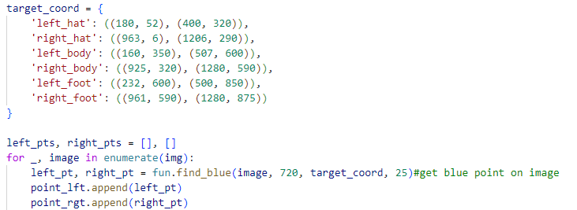

1. Find corresponding point up, vp by epipolar line.

After calculate epipolar line from each uv point, select the point is colest to the line, it’s the up, vp point.

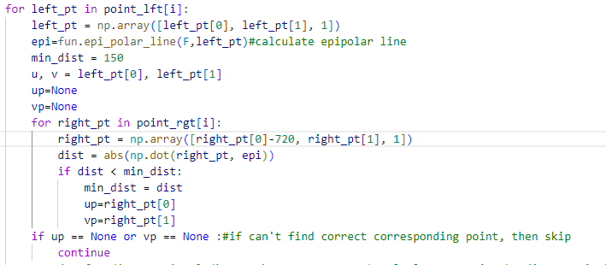

1. Calculate 3D point by direct triangle

After get the corresponding point, calculate the 3D point by direct triangle method, and give the RGB value from first image.

